|  |
| --- |
| Halliburton-Knoesis project |
| Create bug in TFS |
| Guild line for Knoesis’ members |

|  |
| --- |
| Dung Ho  [Pick the date] |

Table of Contents

1. Steps to create a bug in TFS 1

2. Step to get Knoesis log 9

3. Check list for a bug 11

|  |  |  |
| --- | --- | --- |
| Last update | Reason | Date Time |
| Dung Ho | Create Document | 07/31/2013 |
| Hoang Dang | Review Document |  |

# Steps to create a bug in TFS

Step : Open Visual Studio and create a new work item

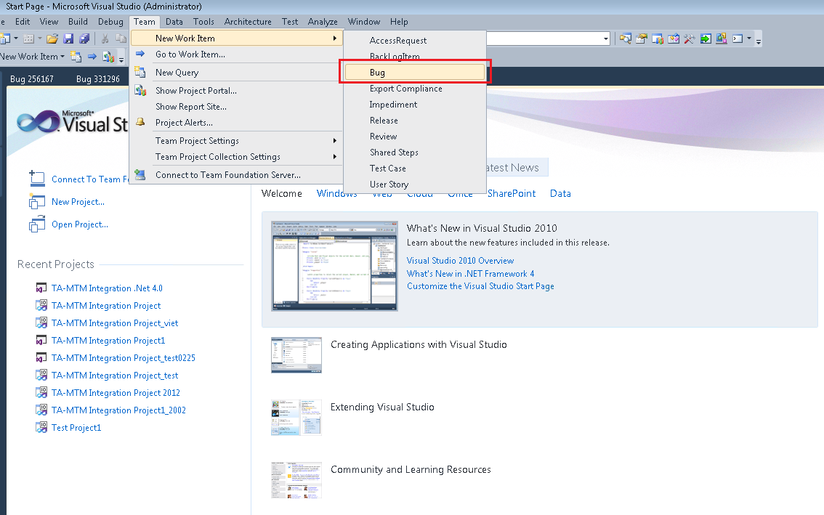

Step : Enter Bug Title

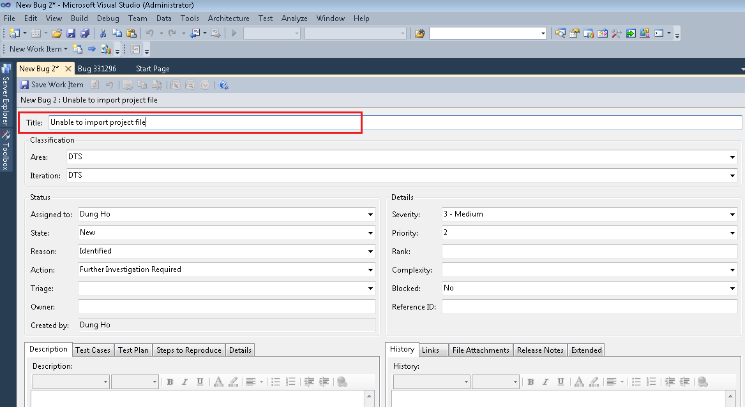

Step : Select the correct Area Path (refer to AreaPathList.docx document):

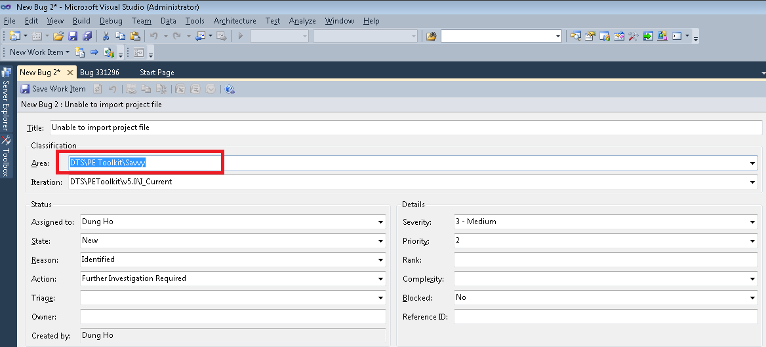

Step : Select current Iteration

Ex: we are working on Knoesis branch build 5.0.0.xxx. We should select: *DTS\PEToolkit\v5.0\I_Current*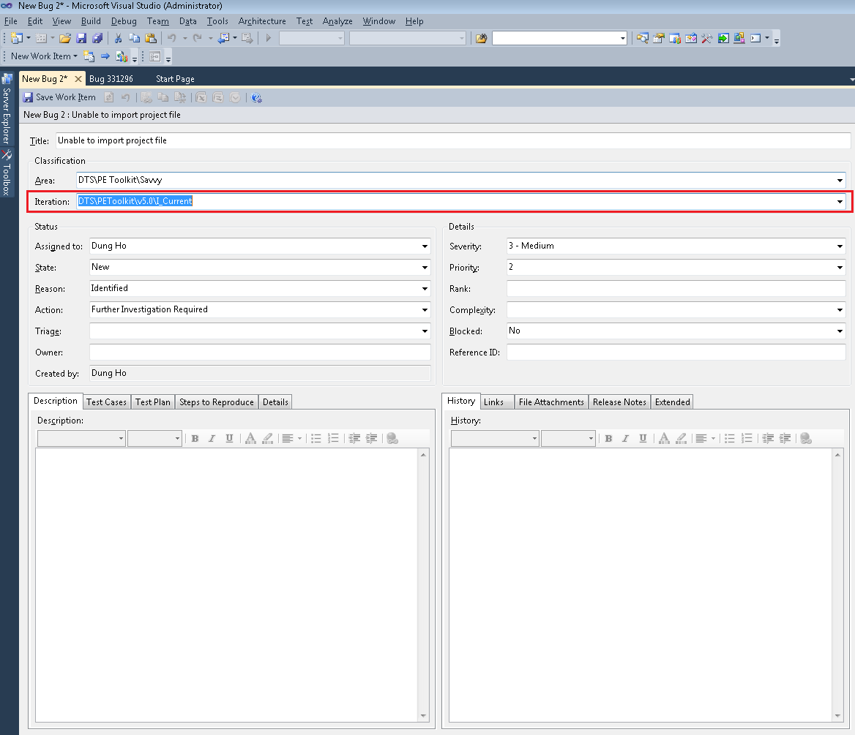

Step :Assign to Test Lead of Area or FDUNTechSoft user

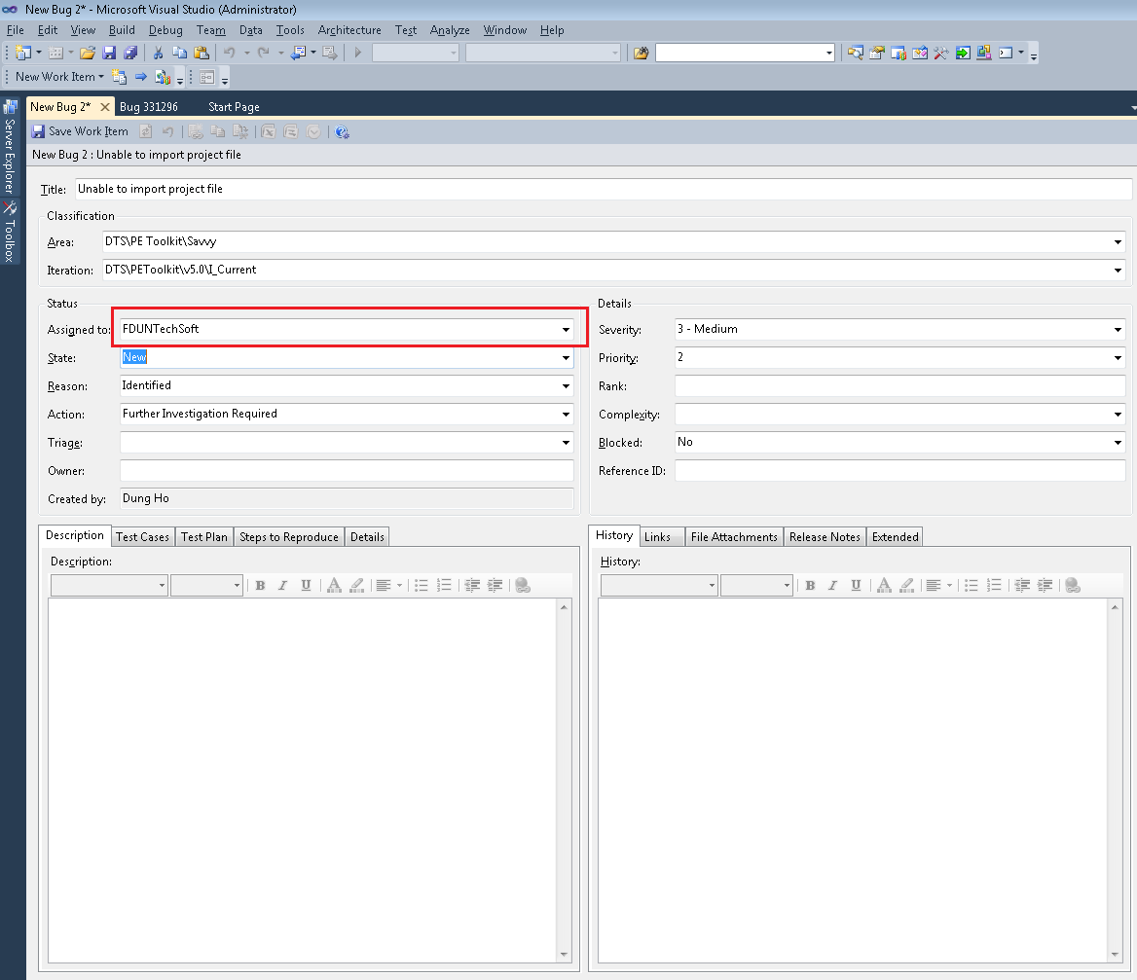

Step : Enter description

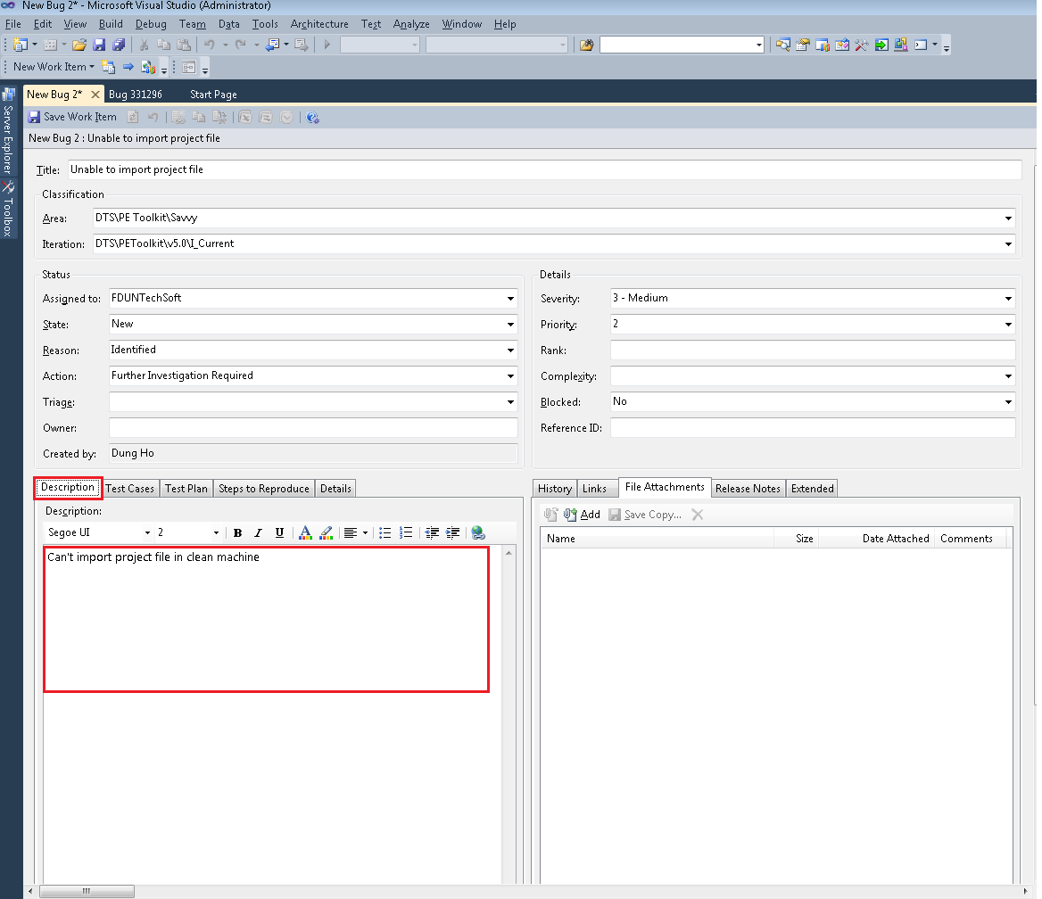

Step : Enter Step to reproduce

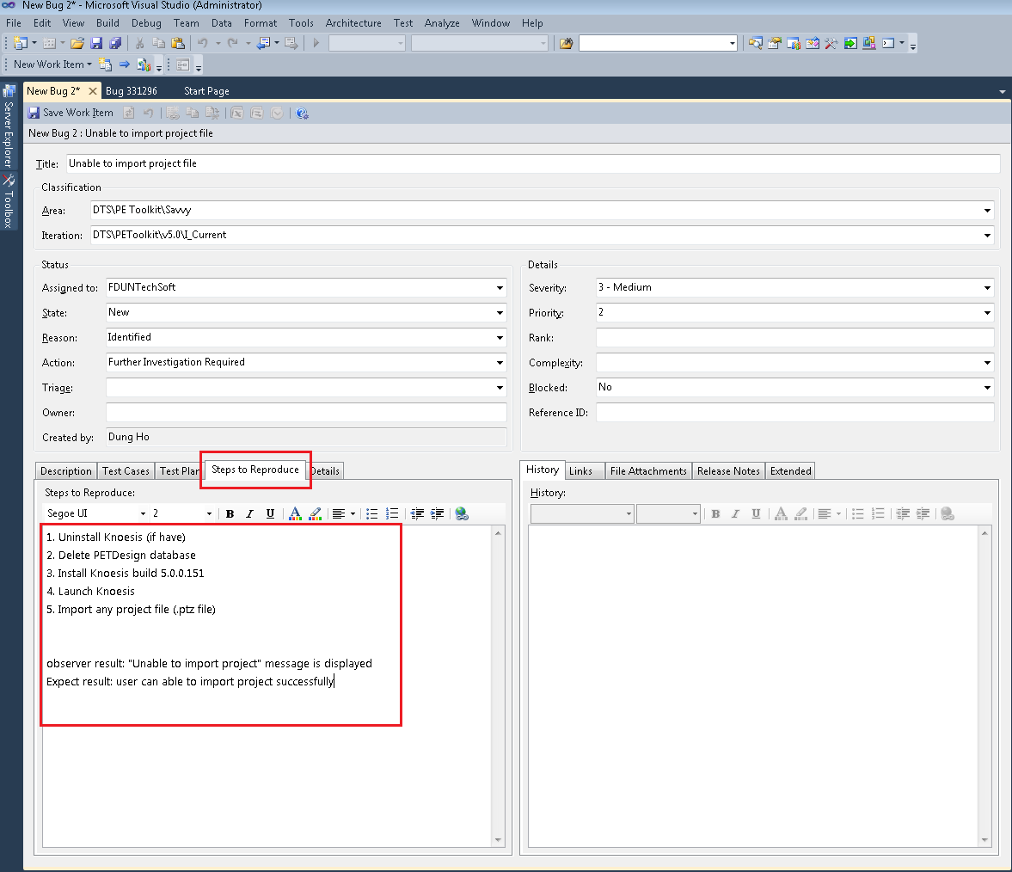

Step : Link to relate Test Case

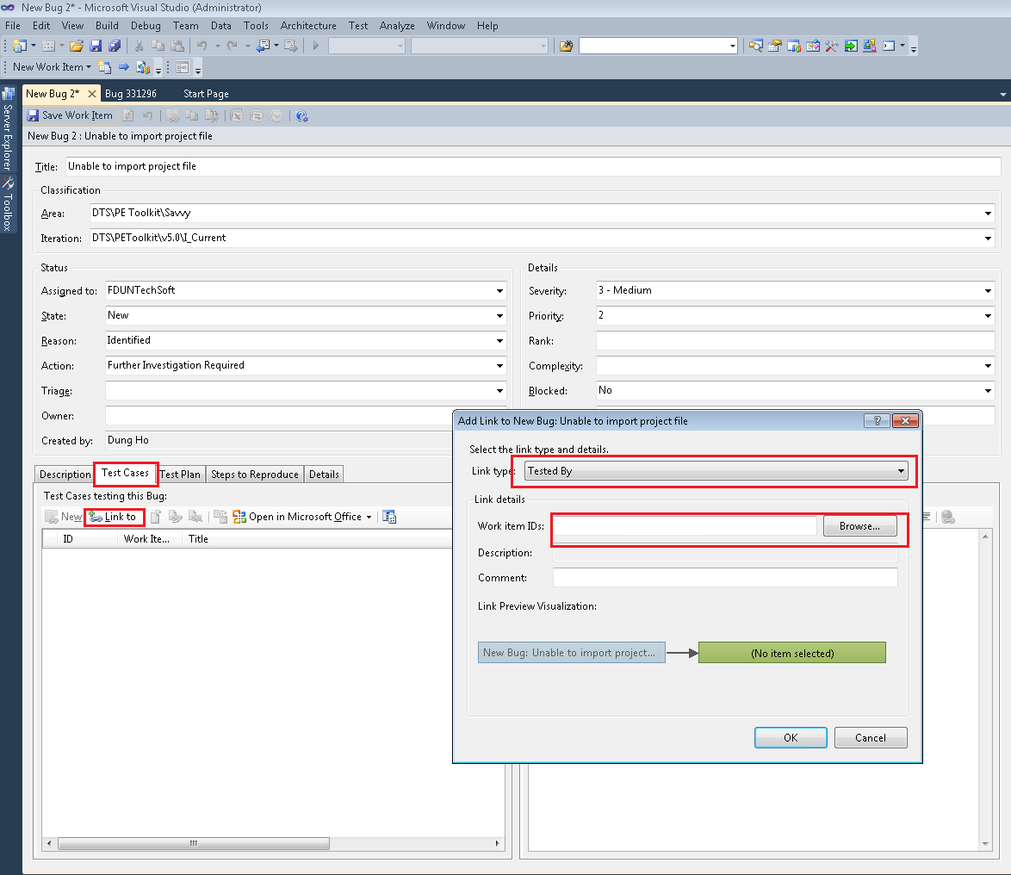

Step : Enter the build number we found the bug

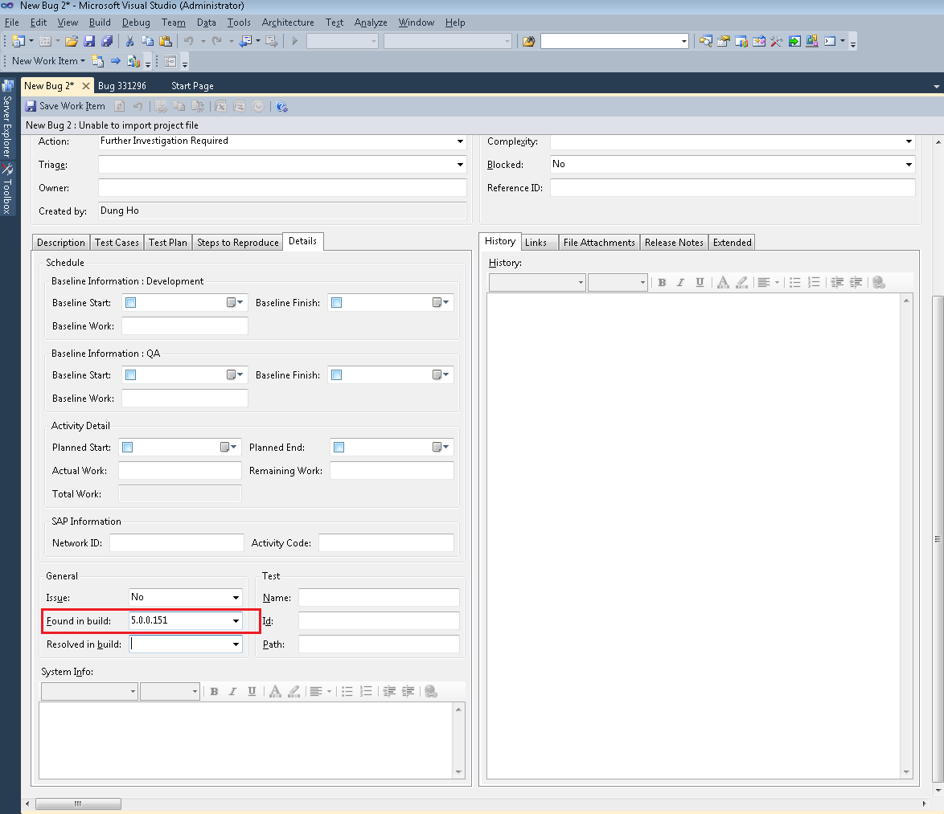

Step : Attach the bug image and log file of machine.

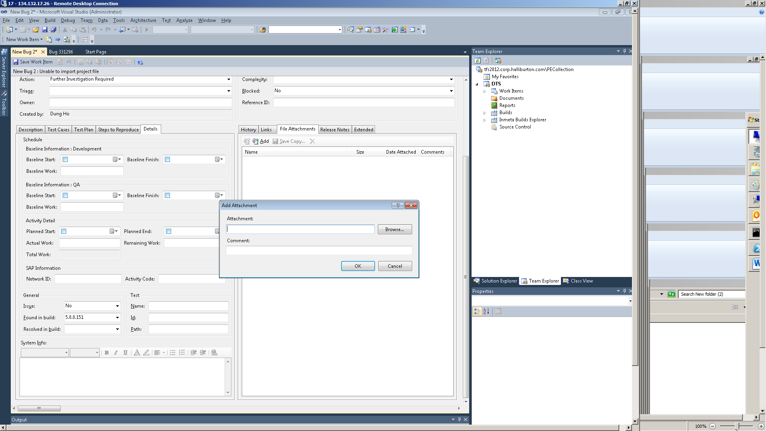

# Step to get Knoesis log

* Enter “%appdata%” in search box of Start menu or go to location: C:\Users\”User”\AppData\Roaming. “User” is current user of machine. Ex: H107739

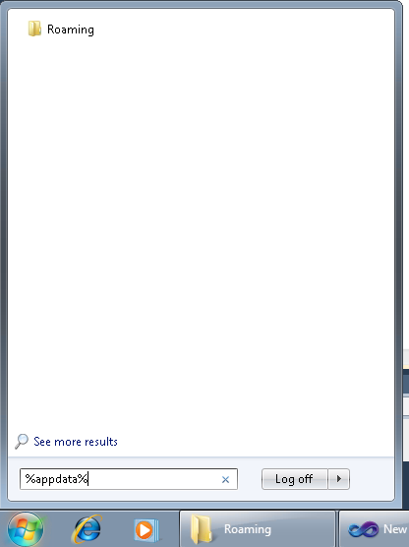

* Select Knoesis folder and get the file: “Knoesis.Shell.log”

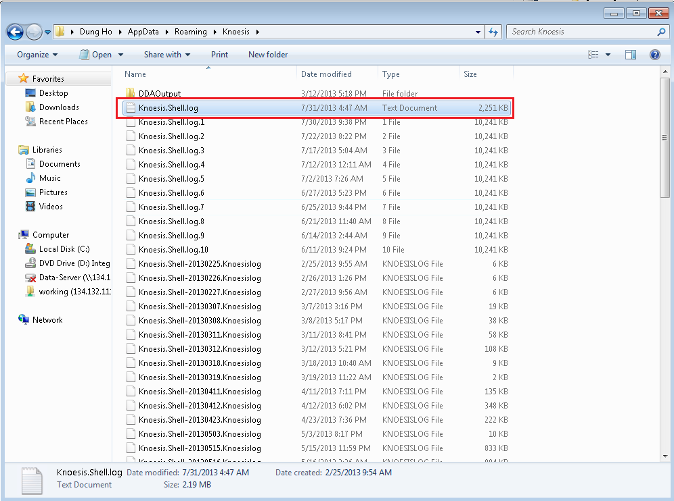

# Check list for a bug

|  |  |
| --- | --- |
| Step | Checked |
| Bug Title |  |
| Correct Area Path |  |
| Correct Iteration |  |
| Assign to test lead or FDunTechsoft |  |
| Enter Bug description |  |
| Link to relate Test Case (If needed) |  |
| Enter Step to reproduce a bug |  |
| Enter Build which found the bug |  |
| Attach Image and Log file |  |

**The End**

**Thanks and regards**